UG Project Plan
CSC-30013/14

Project Overview and Description
Student Name: Edward Pasfield
Student Username: w2i81
Student Number: 1401 4622
Module: CSC-30014
Supervisor Name: James Borg
Project Title: An Artificial Intelligence to play Risk against a user

Please provide a brief Project Description:
An artificial intelligence, to make logical moves against a user(s) at the board game risk. A UI will be needed as to allow a user to actually make moves, drag pieces and roll dice.
I will be using Machine Reinforcement Learning to, through logical trial and error teach an agent to make beneficial actions.
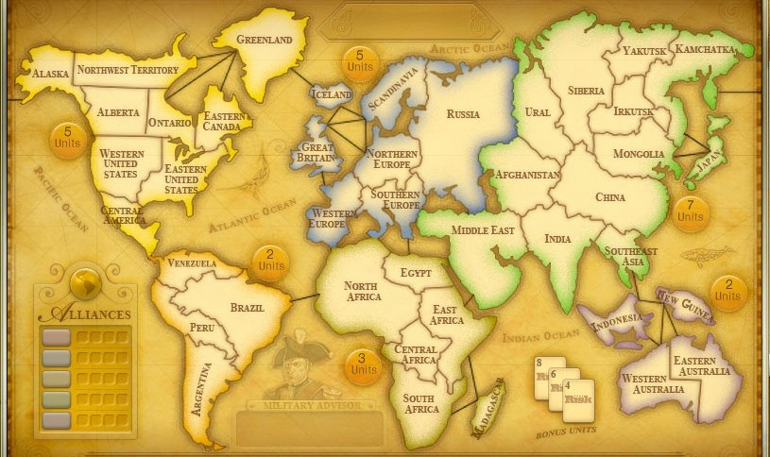

What are the aims and objectives of the Project?
- To create a UI, world map that replicates the board game risk and allows a user to move the three different type of pieces and allow dice rolls/ show the computers rolls.
- To train an Artificial Intelligence to play against a user using reinforcement learning.
- To create a detailed step by step plan, of how I shall be conducting the entirety of my project.

Please provide a brief overview of the key literature related to the Project:
Lots of Machine learning literature, specifically to do with predicting good outcomes of depending on the benefits.

Some related to c++ as to help with the creation of the UI.

http://www.nature.com/nature/journal/v521/n7553/full/nature14539.html - A really good deep learning resource, explains at a basic level what it is. However throughout this reading I realised I wouldn’t be able to back propagate whilst implementing the neural network, which a lot of deep learning relies on. There would be a way of using deep learning on an unsupervised network which would be useful but hard to implement.

https://login.cs.utexas.edu/sites/default/files/legacy_files/research/documents/1%20intro%20up%20to%20RL%3ATD.pdf – Gives a really good basic overview of artificial intelligence and the difference between types. It has lots of good facts and allows the reader to visualise how useful and modern this practice is. However isn’t informative enough for anything other than a few nice facts and figures.

http://ieeexplore.ieee.org/stamp/stamp.jsp?arnumber=7548905 – A Machine Learning article, pdf. It describes the differences between supervised and unsupervised learning and has some very useful figures which I may end up using for my poster.

http://ieeexplore.ieee.org/stamp/stamp.jsp?tp=&arnumber=346412 – MLC++ is explained in detail along with the design of it and how it works, a useful piece of literature when it comes to understanding how to implement a NN in C++

Project Process and Method

Please provide a brief overview of the Methodology to be used in the Project (inc. an overview of best practice within the Methodology):
Prototyping, determine objectives → develop → refine → demonstrate→ test →implement

Reinforcement Learning, Learning through an environment that bases its actions on whether an agents consequences are positive or negative. It uses exploitation (what worked well) and exploration (what it thinks will work well) as a trial and error method of learning. There is a heuristic scale which will be allocated each epoch to the agent and it will try to accumulate the largest amount over a certain amount of moves, as a type of “reward”.

Which Data Collection Methods will be employed (e.g card sorts, questionnaires, simulations, …)?

Questionnaires
Interviews

Time and Resource Planning
Will Standard Departmental Hardware be used? YES
If NO please outline the Hardware/Materials to be used:

Will Software which is already available in department be used? YES
If NO please outline the Software to be used including how any necessary licences will be obtained:

Will the project require any Programming? YES
If YES please list the (potential) Programming Languages to be used (including any IDEs and Libraries you may make use of):
C++

Table of Risks (if non Standard Hardware and/or Software to be used please include backup options/ contingency plans here):

The losing of data is one of my major risks, I shall be backing everything up on google drive and also on a memory stick so I have three copies of all my work just in case.

The learning curve to do with Neural Networks will be hard to overcome, however I have already started research and believe I will be able to do it. Just in case I struggle doing it by myself there are tutorials online I can follow to provide step by step instructions on how to.

My rapport with my supervisor is not a major worry but is in the peripheries, I am a friendly confident person who keeps on top of work. I can’t see us rubbing each other the wrong way. But the best way I can prevent anything happening is to stay well on top of my work and act professionally.

Gantt Chart/ Pert Chart (must include milestones and deliverables):

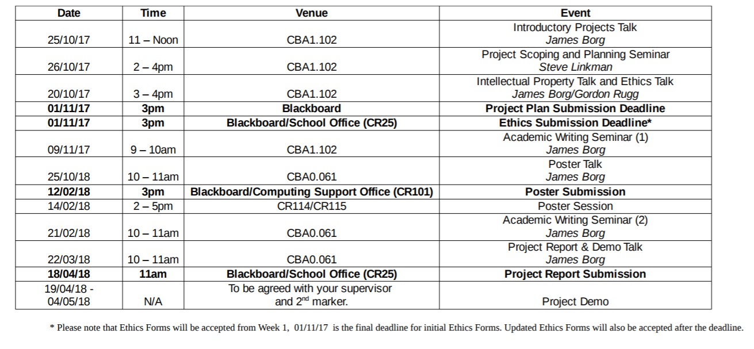
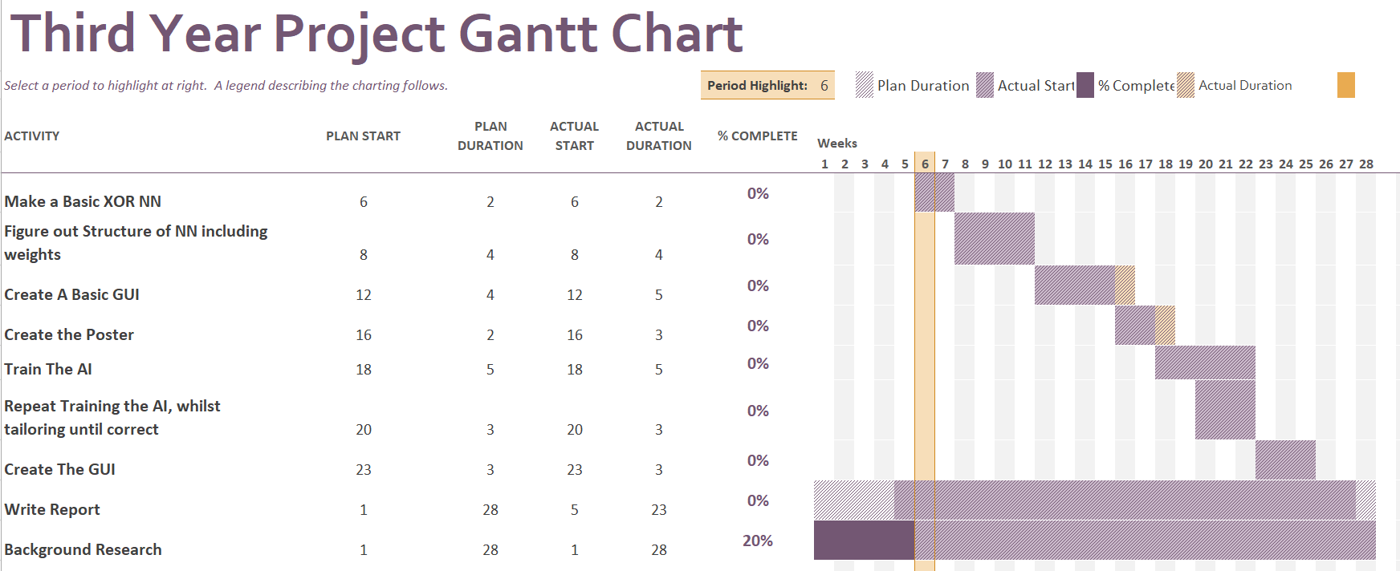

References and Administration
Please include a list of References used in this Plan:

Submission Date: 09/011/2017

PLEASE NOTE THAT SHOULD YOUR PROJECT UNDERGO ANY MAJOR CHANGES FOLLOWING THE SUBMISSION OF THIS PLAN YOU ARE EXPECTED TO SUBMIT AN UPDATED PLAN WHICH ACCURATLEY REFLECTS YOUR PROJECT.
CHANGES IN MODULE FROM CSC-30013 TO CSC-30014 ARE DEEMED TO BE A SIGNIFICANT CHANGE REQUIRING AN UPDATED PLAN.

